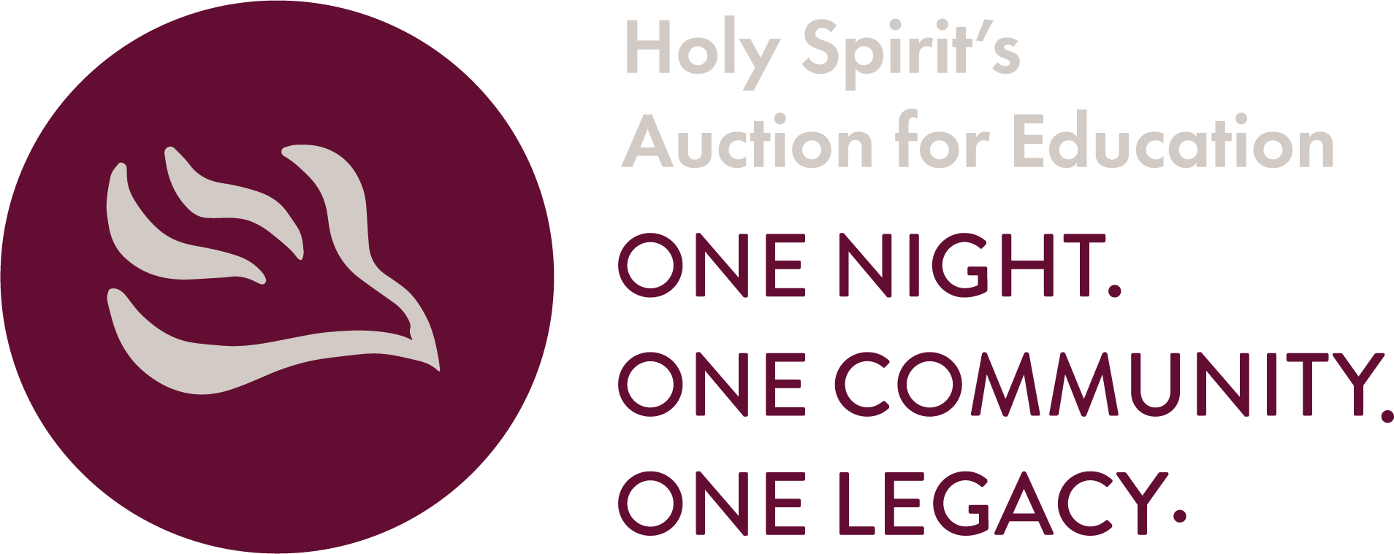
2020 has been a year filled with unprecedented challenges and changes. Through these difficult times, the Holy Spirit community has worked harder than ever before to ensure that every student receives a superior Catholic education. One of the ways that happens is through tuition assistance.

The Holy Spirit Educational Foundation believes that cost should not prevent anyone from receiving a faith-based education. With the mission to “enhance Catholic education opportunities and help make them more affordable at Holy Spirit Parish,” the Foundation has provided over $2 million in support over the years. That support is directed toward tuition assistance and providing opportunities for both the adults and youth of the parish to participate in a variety of faith formation programs.

2019-2020 Foundation Impact:
- 77 students received over $130,000 in need-based tuition assistance.
- 107 students were able to participate in faith formation.
- The Foundation was able to fund 100% of demonstrated financial need for students and their family.
The Holy Spirit Educational Foundation will be hosting its first ever online auction extending from January 26 through January 30, 2021. This event, normally held in person every two years, is the only coordinated fundraising effort for the Foundation. Funds raised from the auction go directly to support tuition assistance and faith formation tuition, in addition to other Holy Spirit ministries. We invite you to share in the important work of the Foundation by becoming a sponsor for our 2021 auction event. Your participation will help ensure the continued support of families at Holy Spirit, which is important now more than ever before.

Due to the change in format for our 2021 event, the benefits of sponsorship have also changed. You will find that information on the enclosed sponsorship commitment form. We hope you will continue to see the benefit in supporting this very important effort. We also hope you will plan to join us for our virtual event in January. Please return your sponsorship information on or before October 25, 2020. If you have any questions please feel free to contact us with any questions.

We’re building something great – be a part of the Foundation!

Sincerely,

Melissa Radlinski
Event Co-Chair
mradlinski@hsparish.org

